# Obendorfer Pumps

## Model N202M Rubber Impeller Pumps for Universal Engines

### General Information

<http://www.downwindmarine.com/Oberdorfer-Model-202M-Rubber-Impeller-Pumps-Universal-Engines-p-91002307.html>

### Bronze Construction with Flange Mount

These engine-cooling impeller pumps are designed specifically for the flange mount of Universal Series gas and marine diesel engines. Direction of shaft rotation determines inlet and outlet ports (see line drawing).

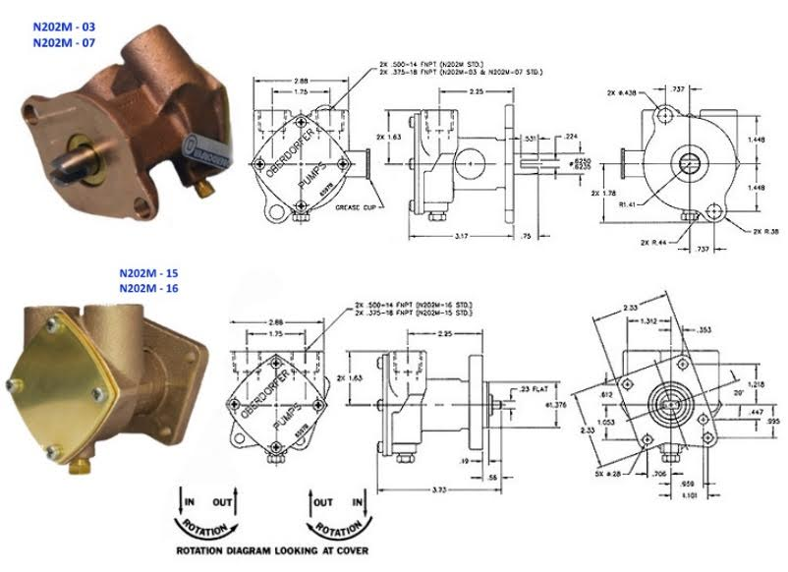

Rubber impeller pumps generate high rubbing friction unless lubricated by pumped liquid. Lack of liquid will cause impeller to burn up. Do Not Run Dry. Liquids compatible with Neoprene can be pumped including fresh and saltwater solutions and mild chemicals. Do not pump severe solvents or acids, and whenever possible, flush pump with fresh water after usage.

On initial start-up, pump must be primed to prevent dry-running of the impeller. Suction lift of 15 feet is possible when impeller is wet. Suction lines must be airtight in order for pump to self prime. A foot valve at beginning of suction line is recommended.

#### Features:

* Corrosion-resistant bronze body
* Rugged simplicity
* Convenient drain plug
* 2-bolt or 5-bolt flange mounting
* Slotted shaft drive or male tang drive
* 2 separate Buna-N rubber lip seals on main pump and flange mounting
* Neoprene impeller (standard)
* High-chrome nickel stainless steel shaft
* Vertical "Up" ports
* Impeller is easily replaced
* Machined-in cam

#### Specifications:

* Maximum pressure to 26 PSI, 60 feet of head
* Temperature limit for bronze pumps is 212° F
* PH-range for bronze pumps is from 4 to 11

|  |  |  |  |  |  |  |
| --- | --- | --- | --- | --- | --- | --- |
| Mfg No. | Ports | Cam | Flange | Shaft | Design Specs for Engines | Universal No. |
| N202M-03 | 3/8-18 FNPT | Half | 2-Bolt | 5/8" with 7/32" Slot | Universal Atomic-4 Series Gas and Marine Diesel | 299805 |
| N202M-07 | 3/8-18 FNPT | Full | 2-Bolt | 5/8" with 7/32" Slot | Universal Atomic-4 Series Gas and Marine Diesel | 299805 |
| N202M-15 | 3/8-18 FNPT | Full | 5-Bolt with Male Pilot | Male Tang | Universal Series with Kubota Diesel | 301357 |
| N202M-16 | 1/2-14 FNPT | Full | 5-Bolt with Male Pilot | Male Tang | Kubota Diesel |  |

Repair Kit of genuine Oberdorfer repair and service parts for these pumps are also available and sold separately - Mfg# 10725, to include:

* Impeller - Mfg #6593
* Lip seals - Mfg #5463
* O-ring - Mfg #9797-034
* Snap (retaining) ring - Mfg #5373
* Also need carbon bearing - Mfg #5091 for N202M-15 (purchase in addition to the kit)

### Seal Replacement

<http://www.ericsonyachts.org/infoexchange/showthread.php?5214-Oberdorfer-Seal-Replacement>

If your pump is like the Oberdorfer pump on an Atomic Four, you can pry the seals out using a flathead screwdriver with the tip bent in a vise at a 90 degree angle about a third of an inch back and tapping each seal out with a hammer.  
  
The outer seal (keeping oil in the engine) is easy to get out. The inner seal (keeping water in the pump) is trickier. The new seals have writing stamped on one side of them. They go in so the letters on the seals face each other. You press the inner seal all the way in with a vise and an appropriately-sized socket. The outer seal is installed flush with the face of the pump - do not countersink it. It is important that the seals be installed square to the shaft, or they'll leak.